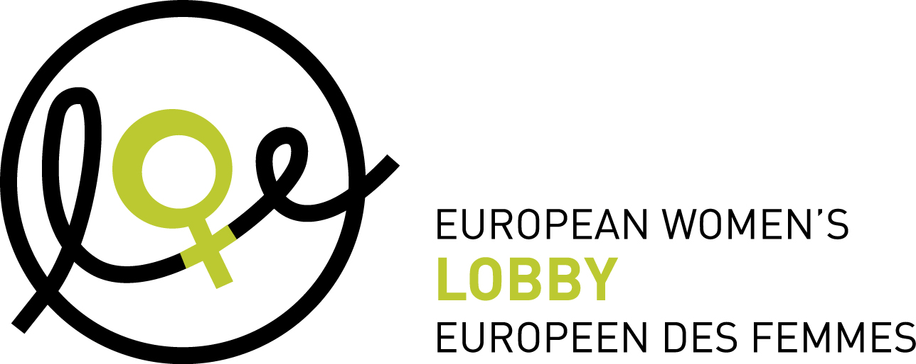

PRESS RELEASE

Brussels, 13 October 2009
In light of EU Anti-trafficking Day 18 October 2009
Issuing Organisations: the European Women’s Lobby

Increased trafficking in women due to EU tolerance for the prostitutional system

According to the UN, 79% of trafficking in human beings is for sexual exploitation. Unsurprisingly therefore, more than 80% of these victims are women. To mark its third Anti-trafficking Day, the EU will hold a Ministerial conference on 19-20 October which will focus on global partnerships from a European security and justice perspective. Commenting on this upcoming event, Brigitte Triems, President of EWL, says: ‘The European Women’s Lobby (EWL) regrets that the conference will not address trafficking in human beings from a gender equality perspective and tackle the real root causes of trafficking in women for sexual exploitation.’

‘It is time for the EU and its Member States, to examine the factors that make them attractive all over the world for trafficking in women for sexual purposes’, declares Colette De Troy, EWL Observatory Director. ‘The EU must recognise that its tolerance for the prostitutional system in Europe, coupled with the persistence of historically unequal power relations between women and men, leads to an amplified acceptance of men’s use of and control over women’s bodies and therefore an increased intensity of male violence against women’.

‘It is therefore not surprising that the lack of EU policy against violence against women has led to an increase in procuring and fuels trafficking in women into Europe for sexual purposes and sex tourism’ explains Brigitte Triems. ‘In order to ambitiously tackle trafficking in women for sexual purposes, the EU must uppermost tackle the demand side of the phenomenon through awareness raising, education to equality and effective sanctions to prostitute-users and procurers.’

As the EU seeks to strengthen its role as a key actor on the international stage, the EWL calls on the EU to affirm its strong commitment to eradicate all forms of male violence against women within its borders, as well as outside its territory. ‘We hope that the EU Ministerial Conference will be the momentum for a concrete strategy to counteract trafficking in women at international level, founded on a strong European commitment to women’s rights to physical, moral and sexual integrity’, concludes Brigitte Triems.

_____________________________________________ends_________________________________________

For more information, please contact Leanda Barrington-Leach, EWL Communications and Media Officer, T: (+32) 2 210 04 41, barrington@womenlobby.org, and see www.womenlobby.org.

Note to editors:
The European Women’s Lobby (EWL) is the largest umbrella organisation of women’s associations in the European Union (EU), working to promote women’s rights and equality between women and men. EWL membership extends to organisations in all 27 EU Member States and the three candidate countries, as well as to 21 European-wide organisations, representing a total of more than 2500 associations.

