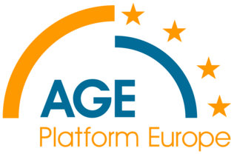
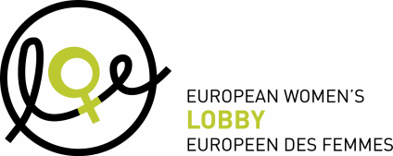

JOINT PRESS RELEASE Brussels, 16 February 2012

White Paper on Pensions
A step in the right direction but more ambition needed
The proposed agenda is a good step in the right direction but for it to deliver, these EU initiatives will need to be supported by a stronger agenda for quality job creation, financial markets regulation and a care economy
AGE, EWL and YFJ welcome the long-awaited White Paper on Pensions, in particular its holistic approach which anchors the objective of pension adequacy, safety and sustainability to the core of the European Annual Growth Survey. We are pleased to see that it includes a strong focus on the need to address gender equality and the gender dimension of labour market participation and its impact on pension income, the promotion of longer working lives through active ageing and solidarity between generations, access to lifelong learning, healthy ageing and better health and safety at work, adaptation of the workplace to older workers’ needs, more flexible working conditions and opportunities for phased retirement, reflecting the main findings of the recent Eurobarometer on active ageing¹.
However the proposed initiatives to enhance the role of complementary private savings in ensuring an adequate, safe and sustainable old age income must be more ambitious on ensuring the safety of pension savings, a crucial issue in today’s economic context and one that requires a thorough gender-equality analysis. Tackling some specific issues around complementary private retirement savings is necessary but not enough to address the concerns of millions of workers and retired women and men across the EU who have seen their private savings erode as a result of financial markets turmoil.
In the last few months, Member States have discovered how interdependent their economies are and know very well now that they can no longer guarantee on their own the adequacy, safety and sustainability of their national pension systems. This is why the proposal agenda on pensions needs to be supported by a stronger agenda for quality job creation including the development of the care economy as well as serious action at EU level to regulate the financial markets and make them serve the economy and the wellbeing of citizens. It is crucial that a sustainable and long-term strategy to guarantee balanced financing of the pension schemes to be based on increasing the young entrants in the labour market and not only on prolonging the pension age. Finally another important point missing in the White Paper is the need to introduce transitional measures over time to ensure that the effort will be fairly spread between generations. The objective of financial sustainability should go hand in hand with social sustainability.

END

Note to the editor

About AGE Platform Europe
AGE Platform Europe (formerly AGE - the European Older People's Platform) is a European network of organisation of people aged 50+ and represents over 30 million older people in Europe. AGE aims to voice and promote the interests of the 150 million inhabitants aged 50+ in the European Union and to raise awareness of the issues that concern them most.
www.age-platform.eu

About the European women’s Lobby
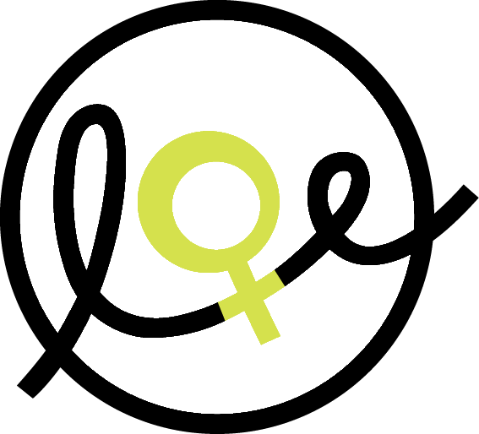
The European Women’s Lobby (EWL) is the largest umbrella organisation of women’s associations in the European Union (EU), working to promote women’s rights and equality between women and men. EWL membership extends to organisations in all 27 EU Member States and three candidate countries, as well as to 20 European-wide organisations, representing a total of more than 2000 associations.
www.womenlobby.org

About the European Youth Forum
The European Youth Forum is the platform of youth organisations in Europe. Independent, democratic, youth-led, it represents 98 National Youth Councils and international youth organisations from across the continent. The Forum works to empower young people to participate actively in society to improve their own lives, by representing and advocating their needs and interests and those of their organisations towards the European Union, the Council of Europe and the United Nations.
www.youthforum.org

For more information, please contact:

Anne Mélard
Information and Communication Officer
AGE Platform Europe (AGE)
www.age-platform.eu
Tel: +32 2 280 14 70
E-mail: anne.melard@age-platform.eu

Anna Elomäki
Communications and Media Officer
European Women Lobby (EWL)
Tel: +32 2 210 04 27,
E-mail: elomaki@womenlobby.org

Letizia Gambini,
Communications Coordinator
European Youth Forum (YFJ)
Tel: + 32 491 04 13 78
E-mail: press@youthforum.org



