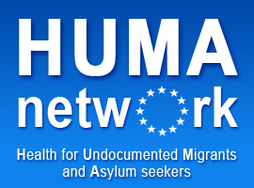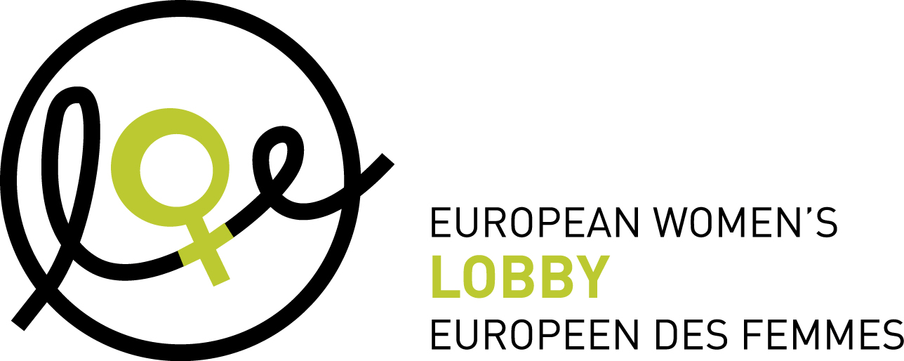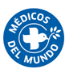

Brussels, 9th of December 2010

PRESS RELEASE

Human Rights Day

9 EU countries do not guarantee access to health care for undocumented pregnant women and children

MEPs join NGOs in urging Member States to tackle health inequalities in access to health care for undocumented children and women

Members of the European Parliament (MEPs) from across the political spectrum were recently confronted with evidence of substantial inequalities in access to healthcare across the EU. A Public Hearing held on 8 December in Brussels highlighted how undocumented migrants – especially undocumented pregnant women and children – are threatened by both legislative and practical barriers when trying to access healthcare. MEPs joined Médecins du Monde, the HUMA network, the Platform for International Cooperation on Undocumented Migrants (PICUM), the European Women's Lobby (EWL) and the European Anti-Poverty Network (EAPN) to call on European and national decision-makers to take action to protect the rights and health of these vulnerable groups, ensuring equitable access to healthcare for all, solidarity and the reduction of health inequalities, and implementing concrete policies with no discrimination linked to administrative status or financial resources.

According to MEP Edite Estrela, rapporteur on the reduction of health inequalities in the EU, “it is inacceptable that, out of 16 countries, nine EU countries (i.e. Cyprus, the Czech Republic, Germany, Greece, the Netherlands, Poland, Slovenia, Sweden and the UK) do not respect the right to health of the children”. Médecins dui Monde/HUMA research on 16 countries also leads to these conclusions.
- In the UK and Greece, women have to pay the full costs of any delivery care they receive from hospitals during childbirth except in emergency cases.
- In Germany, healthcare providers have a duty to report any undocumented migrants they treat, including pregnant women and children, in all but emergency cases.
- In Poland, children of undocumented migrants can only access limited healthcare at school.
- In Sweden, undocumented migrants must bear the full costs of any healthcare services they receive.
Ludovica Banfi, from the EU Fundamental Rights Agency, said that preliminary results of a pan-European study reveal that “in 11 EU countries, there are no specific mechanisms for the children of undocumented migrants: they have no specific protection and are treated as adults”. She underlined for example that undocumented pregnant women in Austria and Greece have by law access only to healthcare in case of delivery complications.
According to the speakers at the Public Hearing, policies restricting the fundamental rights of undocumented migrants have the clear intent to drive them into destitution. “I think it is inadmissible to request care-givers to play the role of immigration policy makers” said Dr Philippe Juvin, an MEP affiliated to the European People’s Party (EPP). “These restrictive policies are pathogenic: they put undocumented migrants in intolerable situations and are contrary to a public health approach”, MEP Hélène Flautre said. According to Dr Hans Wolff, public health expert at the University of Geneva, “it is necessary to ensure equitable access for all people residing in Europe. Otherwise, this will lead to an overuse of emergency services and will also entail a problem in terms of costs. In fact, emergency care is far more expensive than primary care.”

Contact persons:
MdM : Noëlle Rodembourg - (+32) 2 648 69 99
EAPN : Vincent Caron, 0032 496 865 602
EWL : Amandine Bach, 00 32 495 860 436
PICUM: Michèle Levoy, 00 32 486 961 103

You can find it on http://huma-network.org

